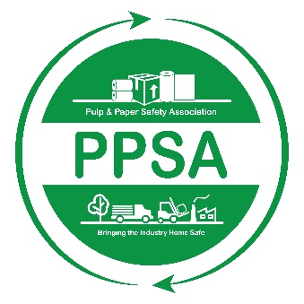

Pulp and Paper Safety Association
Safety Leader of the Year Award
2023-2024

The PPSA would like to recognize outstanding achievement within the safety profession with the Safety Leader of the Year (SLY) Award. The SLY Award recognizes a single forest products industry leader who has demonstrated unique, engaging, and effective approaches to the safety programs within their company. In doing so, this individual has had a profound and positive impact on safety within the forest products industry.

Eligibility: in order to qualify the individual must meet the following criteria:

- The individual’s site or company must be an active member of the PPSA.
- The individual must be a full-time employee in a leadership role (i.e. safety professional, lead worker, safety committee member, etc.) who is involved with their company’s safety efforts.
- The individual is not currently serving on the PPSA Board of Directors.
- Executive Eagle Award winners are not eligible.

Nomination: An individual meeting the eligibility requirements noted above can be nominated by a co-worker by completing the PPSA- Safety Leader of the Year Award: Nomination Form. This form is available on-line at www.ppsa.org. Applications must be submitted electronically to the PPSA Member Relations Manager Hannah Peterson hpeterson@ppsa.org by May 10, 2024.

ALL NOMINATIONS MUST BE RECEIVED IN THE ASSOCIATION OFFICE BY APRIL 2, 2024.

Safety Leader of the Year Award
Nomination Form

This form can be completed by any co-worker or associate (herein after referred to as the Sponsor) of the Nominee.

Sponsor Information:
Name:
Address:
Phone:
Email:
Title:
Company Name:

Nominee Information:
Name:
Address:
Phone:
Email:
Title:
Company Name:

Attachments: the following information regarding the nominee shall be provided:
- Nominee’s Organization Chart; and
- Written description of the nominee’s current job/position; and
- Nominee’s resume or other document outlining their professional background; and
- A petition of the nominee’s achievements, influence and impact on safety within the forest products industry. The petition shall be submitted typed on 8.5 x 11-inch paper.
- Letter of support from nominee’s supervisor

All applications submitted by May 10, 2024, will be reviewed by the PPSA Board of Directors. A winner will be chosen, and the SLY Award will be presented at the 2024 PPSA Safety and Health Conference.

