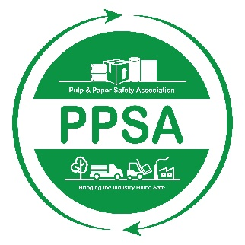

**Pulp and Paper Safety Association**

**Industry Safety Committee/Team Award  
2024-2025**

This award honors a pulp & paper industry safety committee/team that has made a significant contribution to safety & health at their location, company, or within the industry. In order to receive this award, a committee/team must apply for it, be selected as a finalist by the PPSA awards committee and lastly receive the most votes by PPSA annual conference attendees and a panel of the Board of Directors. The winning site will receive the Industry Safety Committee/Team Award and be highlighted on the PPSA website and upcoming quarterly report.

To apply for this award, please complete this form and submit it along with your accompanying information via [**email**](mailto:info@ppsa.org) **or regular mail no later than *May 10, 2025***:

PULP & PAPER SAFETY ASSOCIATION

15 Technology Parkway South

Suite 115

Peachtree Corners, GA 30092

[info@ppsa.org](mailto:info@ppsa.org)

**Eligibility:**

* Submitting facility must be a PPSA member site at the time of submission of this application. Go to [ppsa.org](http://www.ppsa.org/become-a-member) to become a member!
* All applicants must agree to share their submission with the PPSA membership regardless of whether they are selected as a finalist. PPSA will honor requests to not share any copyright and/or patent information.
* A committee/team is eligible to apply for the award only once every three years.

**ALL NOMINATIONS MUST BE RECEIVED IN THE ASSOCIATION OFFICE BY MAY 10, 2025 FOR THE PRECEDING AWARD YEAR.**

**Industry Safety Committee/Team Award**

**APPLICATION FORM**

**Please complete the following:**

Committee/team being nominated:

Company:

Address:

Phone:

Email:   
__________________________________________________________________________________

Your name:

Company:

Your job title:

Address:

Phone:

Email:

__________________________________________________________________________________  
 **Specific Information for the Safety Committee/Team Award**

Please include the following information when submitting this form: *(Be as specific as possible. Nominations are judged on the information you submit.)*

* **Provide** the mission statement or charter of the safety committee/team you are nominating.
* **Describe** any innovative activities the safety committee/team has engaged in.
* **Describe** any activities taken place to involve non-committee employee engagement.